Set 6: Product Sales Analysis
Dataset: Monthly Product Sales
Product ID | Product Name | January Sales | February Sales | March Sales
1 | Product A | 2000 | 2200 | 2400
2 | Product B | 1500 | 1800 | 1600
3 | Product C | 1200 | 1400 | 1100

Question 1: Grouped Bar Chart of First Quarter Sales
Create a grouped bar chart to visualize the sales of each product for the first quarter. Label the chart elements.
Answer:
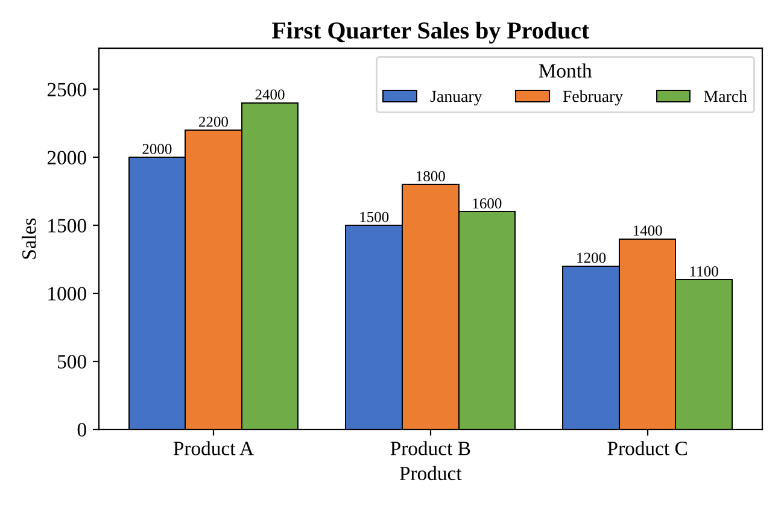
Product A sold more in every month, rising from 2000 in January to 2200 in February and 2400 in March. Product B increased from 1500 to 1800 in February and then fell to 1600 in March. Product C rose from 1200 to 1400 in February and dropped to 1100 in March, its lowest value of the quarter. Product A therefore has the highest sales throughout, and Product C the lowest.
Question 2: Stacked Area Chart of Overall Sales Trend
Generate a stacked area chart to represent the overall sales trend for all products over the three months.
Answer:
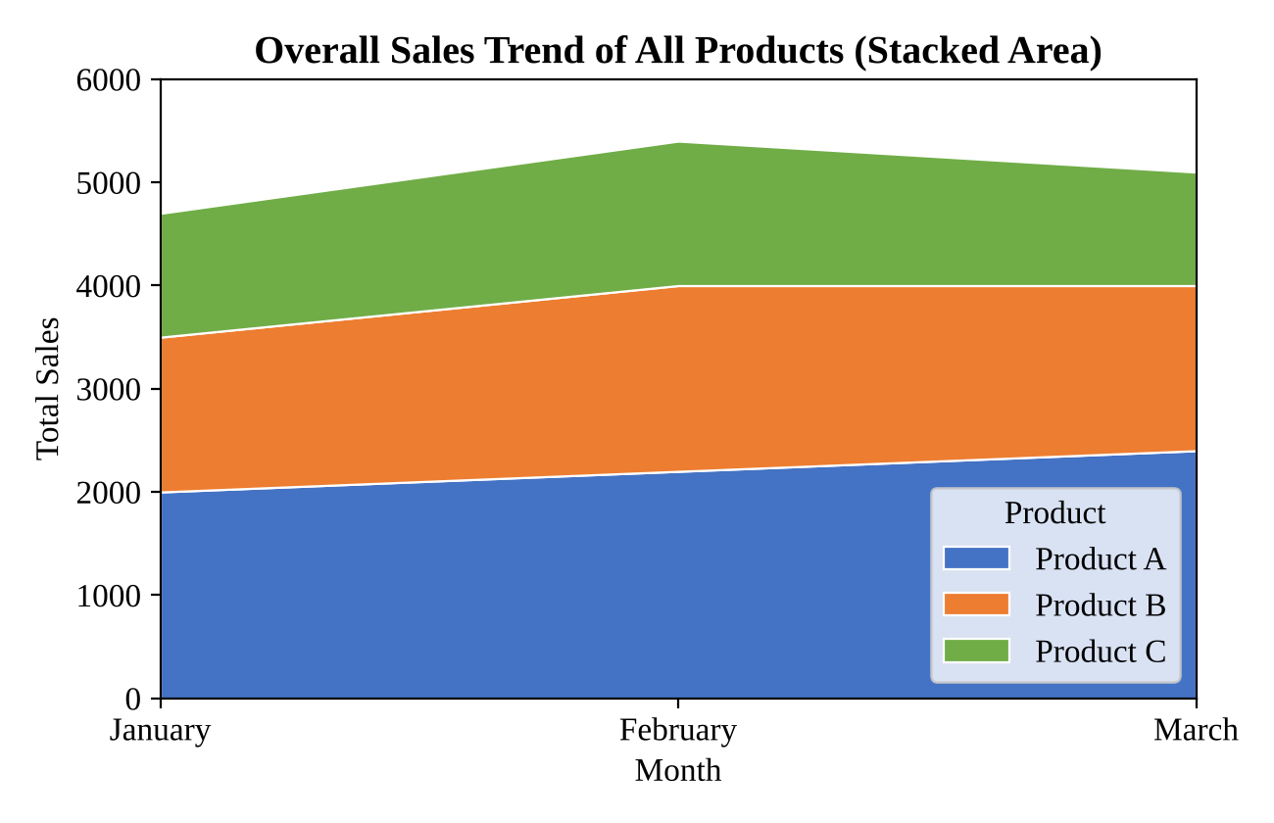
Combined sales of all three products were 4700 in January, 5400 in February and 5100 in March. This is an increase of 700 (about 14.9%) from January to February, followed by a fall of 300 (about 5.6%) in March. The March decline comes from Products B and C, since Product A kept growing. Product A forms the largest layer of the chart in every month.
Question 3: Table of Monthly Sales Data
Build a table to show the monthly sales data for each product. Label the table elements.
Answer:
Table 1: Monthly Sales Data by Product
Product | January | February | March | Total
Product A | 2000 | 2200 | 2400 | 6600
Product B | 1500 | 1800 | 1600 | 4900
Product C | 1200 | 1400 | 1100 | 3700
Total | 4700 | 5400 | 5100 | 15200

The rows list the products, the columns list the three months, and the last row and column give the totals. Over the quarter, Product A contributed 6600 (about 43.4% of the total), Product B 4900 (about 32.2%) and Product C 3700 (about 24.3%), making a grand total of 15200.
Question 4: Tableau Dashboard
Develop a Tableau dashboard combining the grouped bar chart, stacked area chart, and the table for interactive exploration of sales data.
Answer:
Tableau is a desktop application, so the dashboard file itself cannot be created inside this document. The preview below shows the intended layout, and the steps explain how to build it.
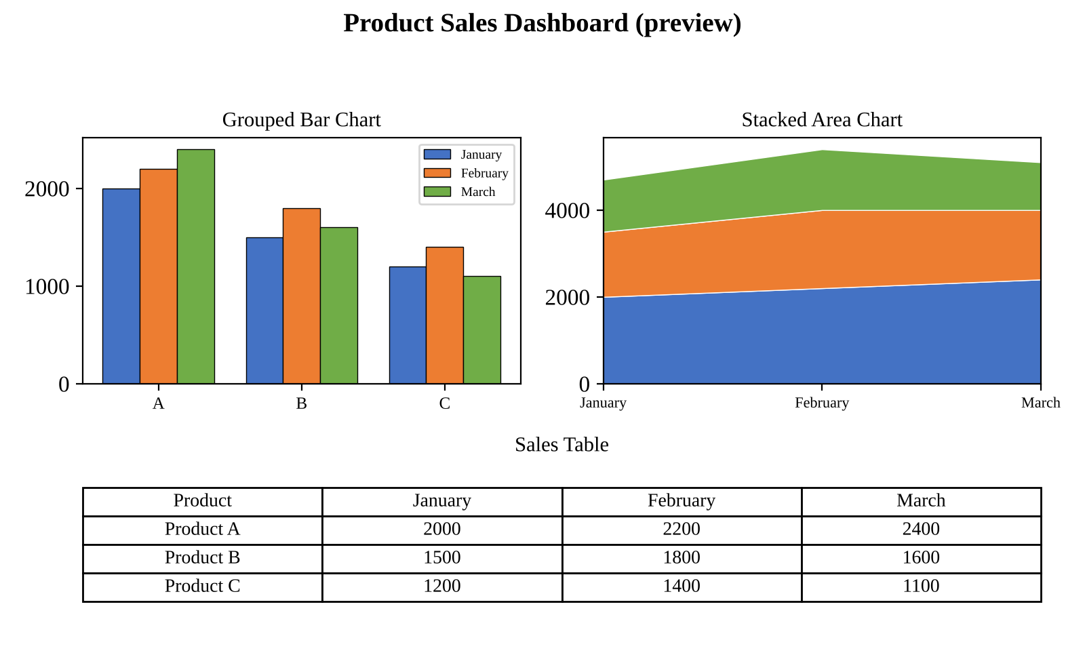
- Open Tableau and connect to product_sales_long.csv. The months are placed in one column (Month) so that Tableau can use them as a field.
- Sheet 1 (grouped bar): drag Product Name and then Month to Columns, drag Sales to Rows, and put Month on Color. Show the value labels.
- Sheet 2 (stacked area): drag Month to Columns and Sales to Rows, put Product Name on Color, and choose Area on the Marks card. Sort the months from January to March.
- Sheet 3 (table): drag Product Name to Rows, Month to Columns and Sales to Text. Turn on Grand Totals from the Analysis menu.
- Create a new dashboard, drag the three sheets onto it, turn on “Use as Filter” for each, and add a Product Name filter.
- Add a dashboard title, then save the workbook (.twbx) or publish it to Tableau Public.

